**Galactic Trailblaze🚀**



**Description📜:-**

Welcome to Galactic Trailblaze, an immersive 3D web-based application that brings the solar system and exoplanetary discoveries to your screen. This interactive tool allows users to explore planets, stars, and exoplanetary systems with real-time simulations of celestial bodies and their orbital paths. Gain detailed insights into each planet's characteristics and simulate their positions in space over time.

**Features💡:**

* **Interactive 3D View:** Real-time 3D visualization of the solar system and known exoplanets.
* **Detailed Exploration:** Select and view information on each planet and exoplanet, including orbits and key stats.
* **Dynamic Controls:** Zoom, pan, and rotate through the vastness of space, exploring star systems from any angle.
* **Orbital Simulation:** Visualize and simulate the motion of planets over time.
* **Exoplanet Exploration:** Dive into exoplanetary systems with confirmed discoveries beyond our solar system.

**Getting Started⭐:**

**Prerequisites**

To run Galactic TrailBlaze, you will only need:

* A modern web browser with **WebGL support**.
* Thats all, Really :)

**Installation🔪**

1. Clone the repository to your local machine:

git clone https://github.com/ArjiJethin/NASA-SpaceApps.git

1. Navigate to the project directory:

cd NASA-SpaceApps

1. (Optional) Install dependencies for local development [idk if u want to work on this, but go for it :) ]

* npm install

**Usage🔥:**

1. Simply open index.html in your browser to launch the 3D viewer.
2. Use the intuitive controls to explore various planets and exoplanetary systems.

**Contributing✒️**

We welcome contributions from the community! To get started:

1. Fork the repository.
2. Create a new branch for your feature or fix:

git checkout -b feature-branch

1. Make your changes and commit them with a clear message:

git commit -m "Add new feature"

1. Push to your branch:

git push origin feature-branch

1. Create a pull request for review.

**Check Out the Live Site:**

You can explore the Galactic TrailBlaze live by visiting the following page [Click here](https://galactictrailblaze-arjijethin.netlify.app/)

**Details📄:-**

**⦾ SignUp & SingIn Pages📝:-**

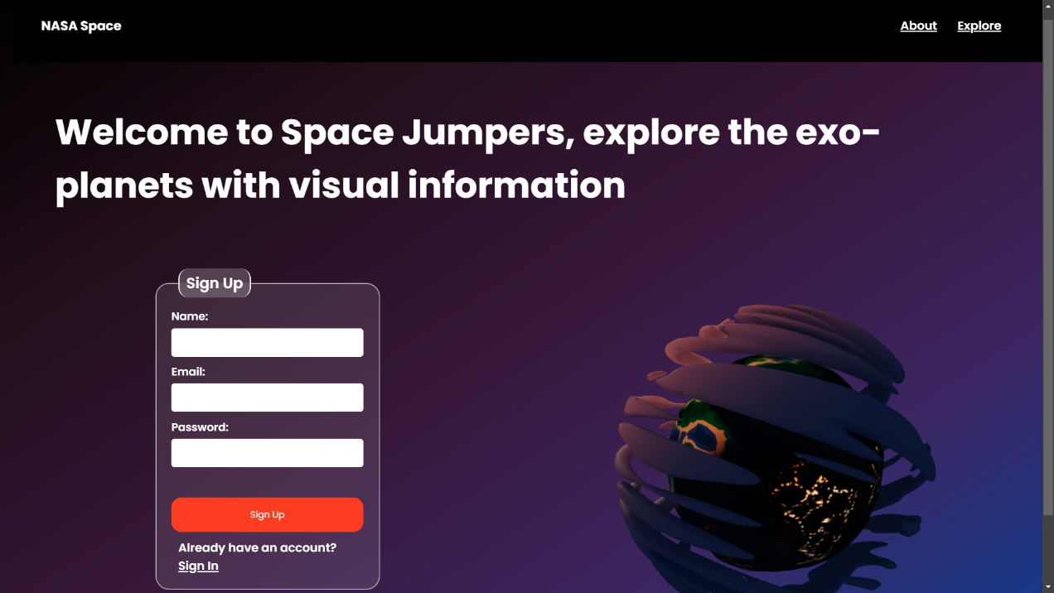

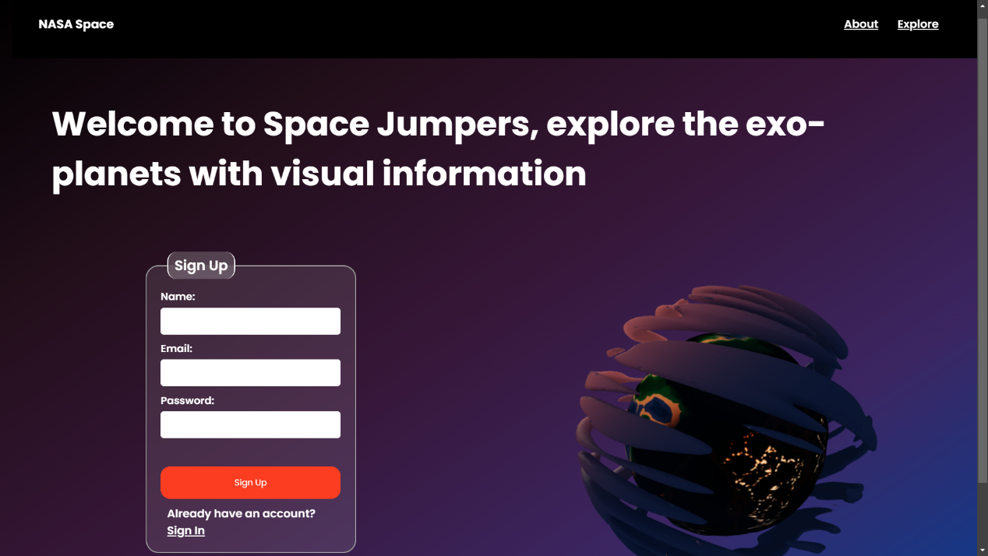

The SignUp page is used to create a new account for the user. The SignIn page is used to log in to the user's account.A dtabase can be added and we are thinking about its addition to the page later in the future.

**⦾ About Page📰:-**

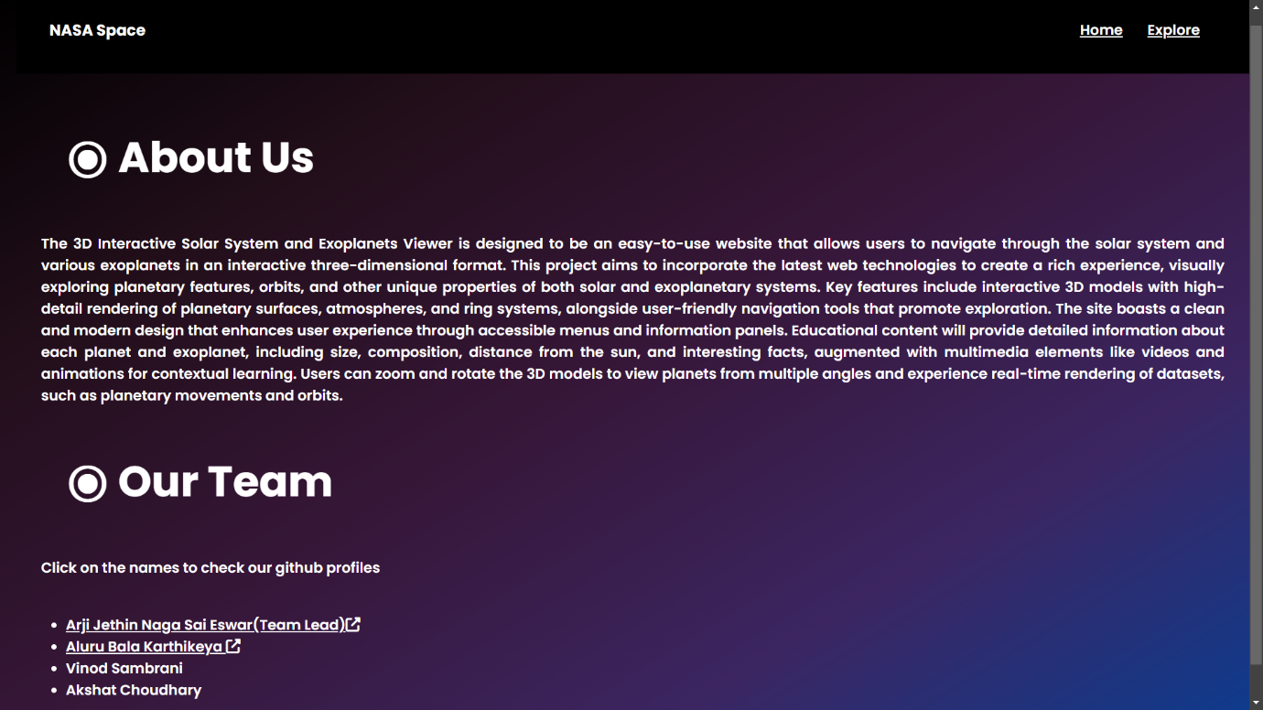

This page is just information about the webpage and details regarding the people that participated in the project

**⦾ NasaTerminal Page🛰️:-**

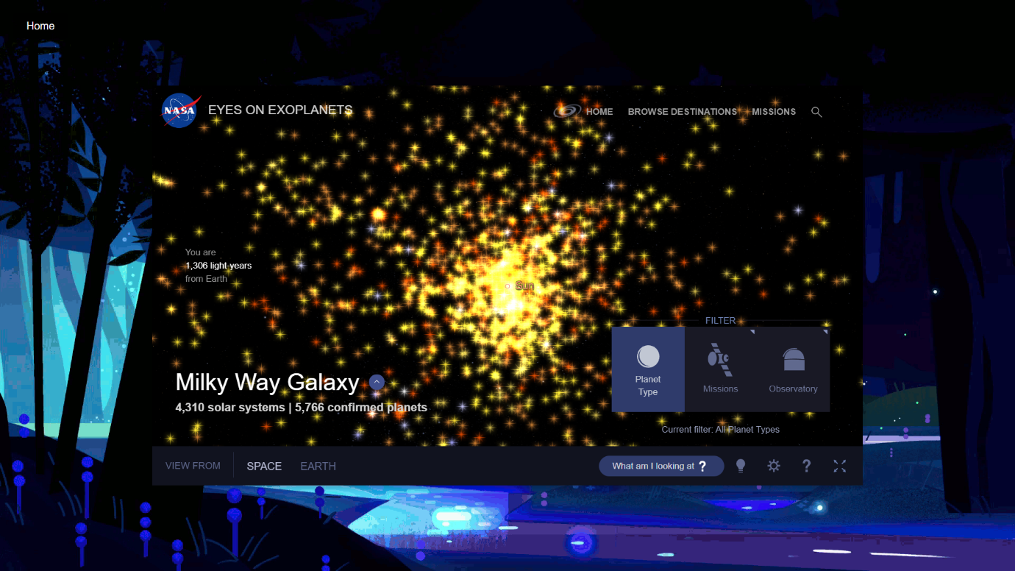

This NASA Terminal page is connected to the NASA API and can be used to get information about the planets and stars in the solar system.

**⦾ Home Page🏡:-**

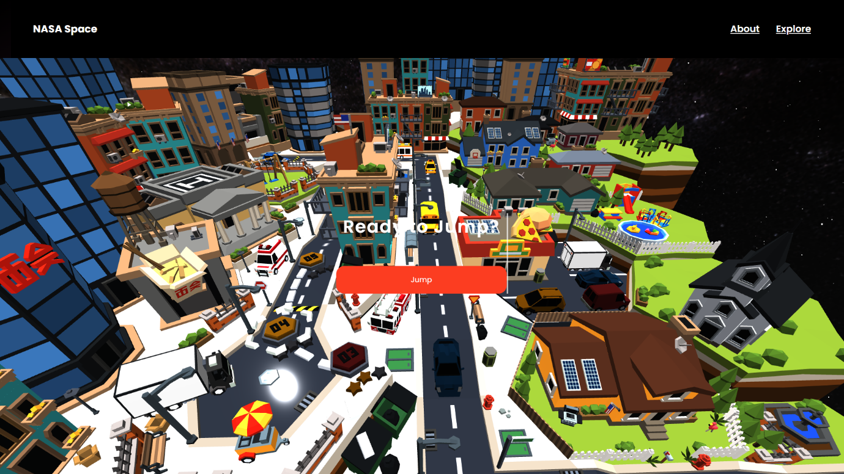

This Home page has a 3d model of a city with link to an the main 3d model pages

**⦾ Earth Page🌏:-**

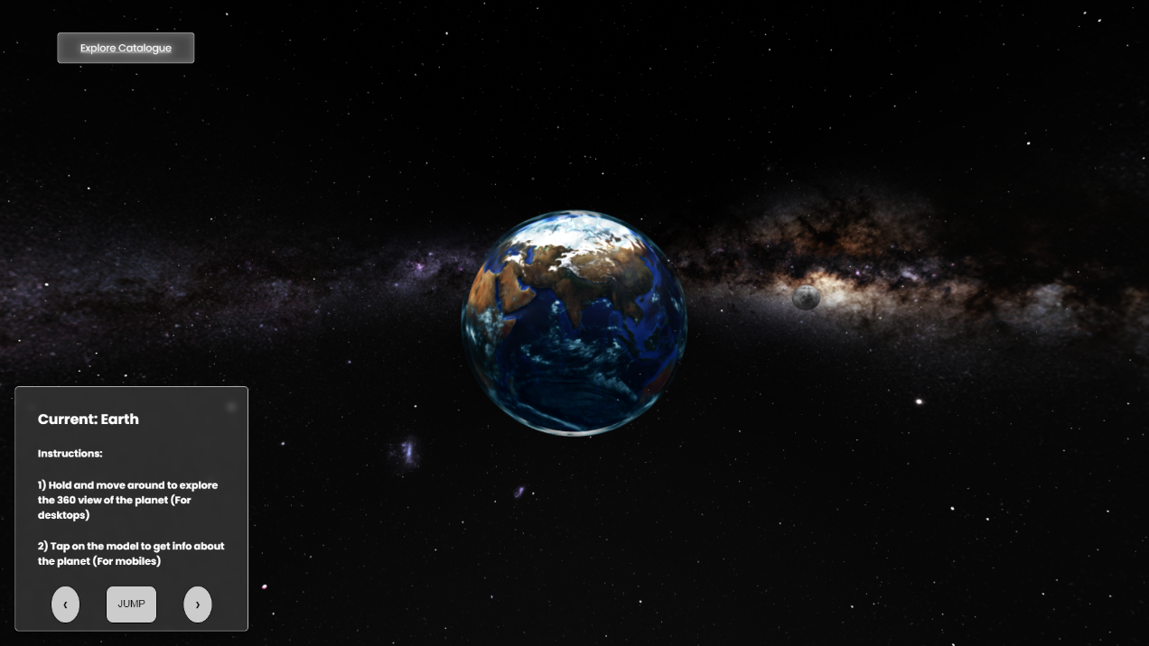

This Earth page has a 3d model of the earth with information about the earth and you can interact with the 3d model of the earth and see the information about the earth.The user can navigate through the planets using the List Template given in the bottom left corner

**Navigation and Additional Planets:-**

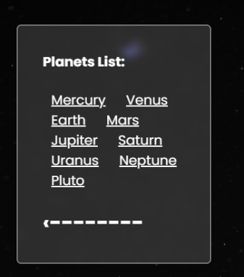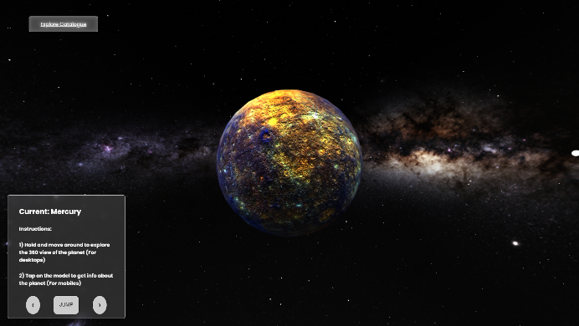

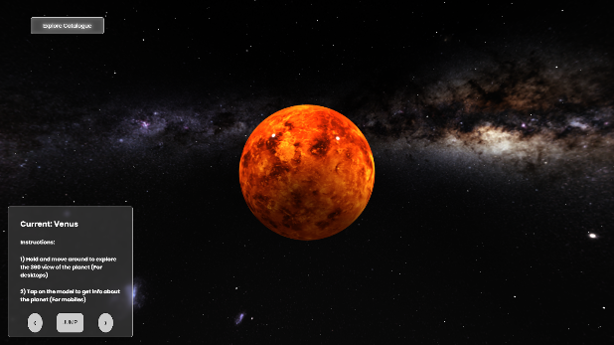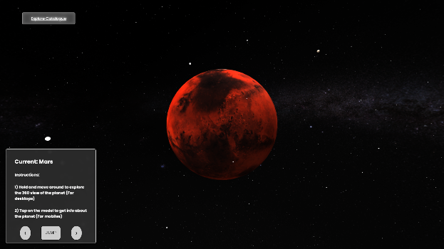

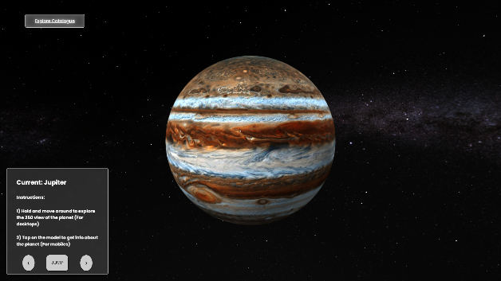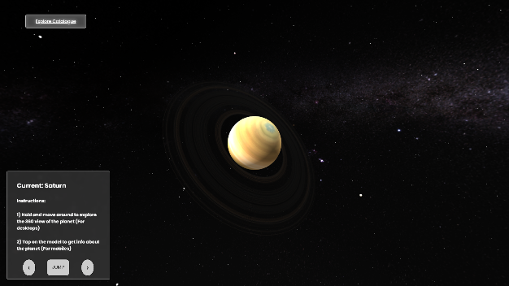

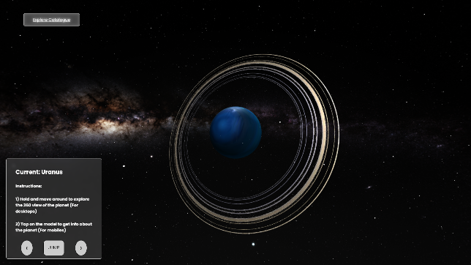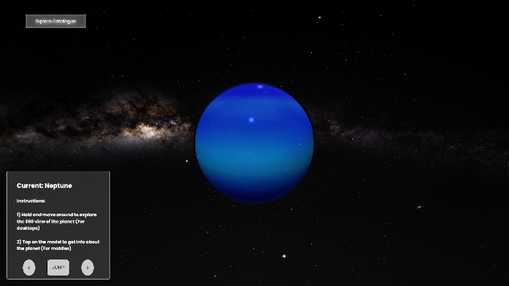

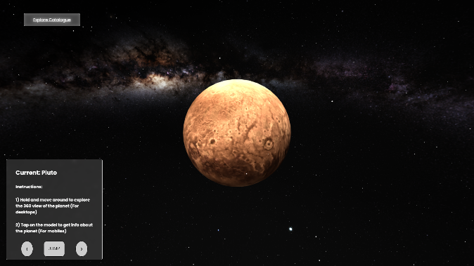

**⦾ Catalogue Page📇:-**

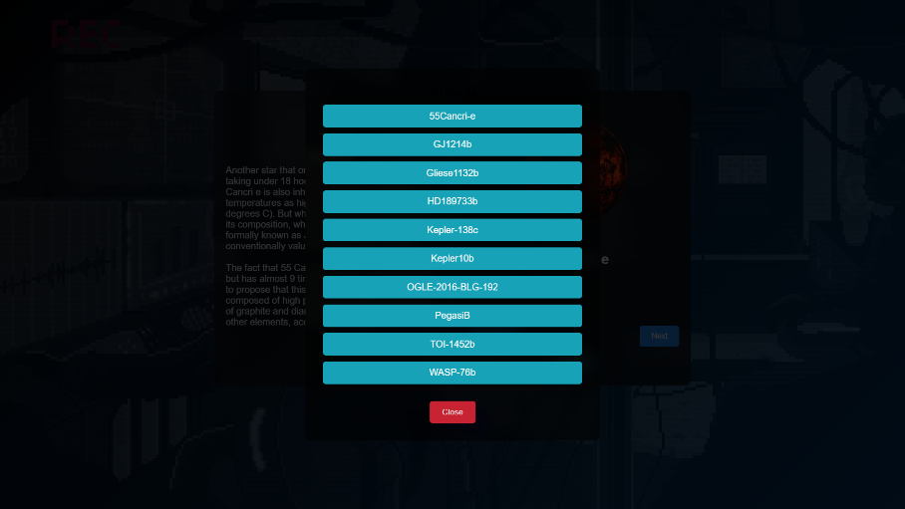

**This page has a Catalogue of all the exoplanets that were shown in the website and a breif description about them with links to them. You can navigate through the planets using the List Template given.**

**Exoplanets given in the Website:-**

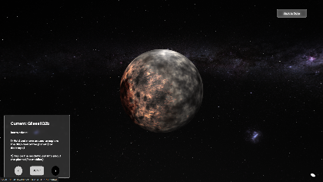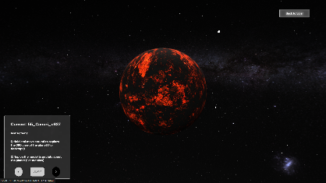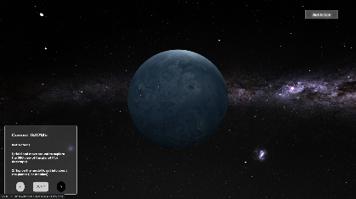

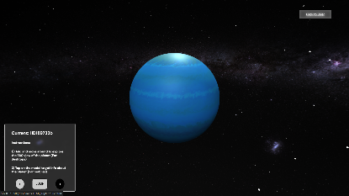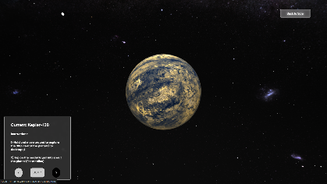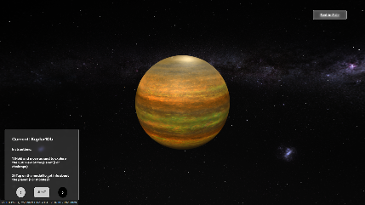

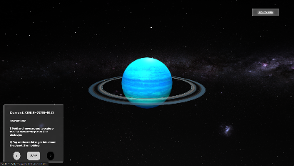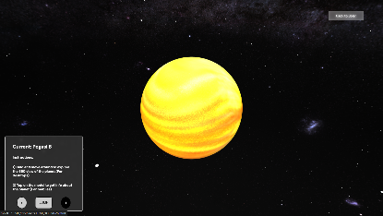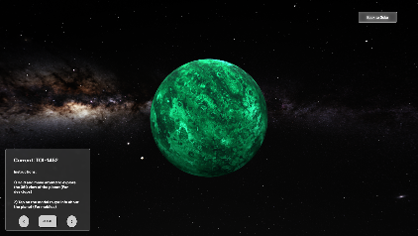

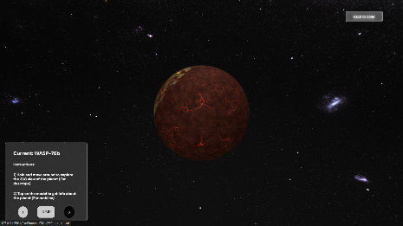

**Conclusion☄️:**

Galactic TrailBlaze is more than just a tool for visualizing planets, it is an interactive gateway to the wonders of our solar system and the fascinating discoveries of exoplanets beyond. Whether you're a space enthusiast, a student, or a researcher, this application offers a user-friendly yet scientifically accurate experience that brings the universe closer to your fingertips. As we continue to explore and learn more about the cosmos, Galactic TrailBlaze will evolve and grow, providing up-to-date features and functionality.

We hope this project sparks curiosity and provides an engaging way to explore the incredible beauty and complexity of space. Feel free to contribute, offer suggestions, or reach out to the team for collaboration. Together, we can expand our understanding of the universe. Keep exploring!